**ANALYTICS FOR HOSPITAL'S**

**HEALTH-CARE DATA**

**PROJECT DESIGN PHASE -II**

**Technology Architecture**

|  |  |
| --- | --- |
| DATE | 17 October 2022 |
| TEAM ID | PNT2022TMID47568 |
| PROJECT NAME | Analytics for Hospitals’ Health-care data |
| MARKS | 4 Marks |

**M.KRISHNAKANNAN.**

Final year CSE Student,

Latha Mathavan Engineering College, Madurai.

**T.PRAKASH.**

Final year CSE Student,

Latha Mathavan Engineering College, Madurai.

**Technical Architecture:**

The Deliverable shall include the architectural diagram as below and the information as per the table1 & table 2.

**Example: Analytics for hospital’s health care data**

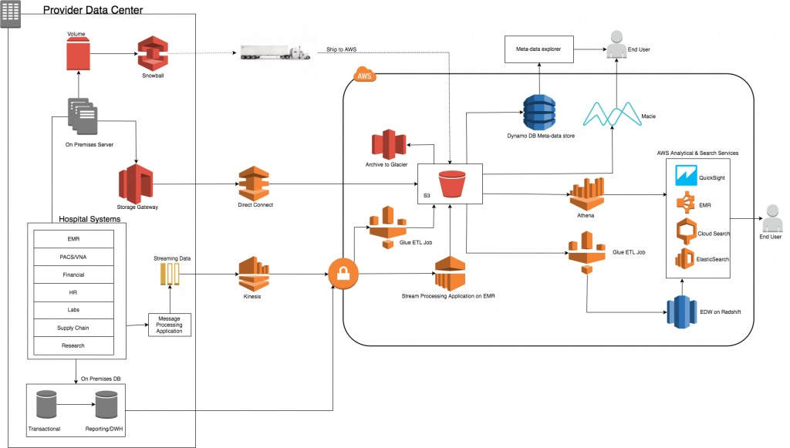

**Guidelines:**

* Harmonizing healthcare-specific data types.
* Developing portable cohort definitions, clinical measurement. definitions, and dashboards.
* Providing relevant datasets for integration into your analytics.
* Secure sharing of aggregated data subsets with others.

**Table-1 : Components & Technologies:**

|  |  |  |  |
| --- | --- | --- | --- |
| **S.NO** | **Components** | **Description** | **Technology** |
| 1 | User Interface | Dashboard | Python |
| 2 | Database | Patients Medical History | MySQL |
| 3 | Cloud Database | Database Service on Cloud | IBM Cloud |
| 4 | File Storage | File Storage  requirements | Local file system |

**Table-2: Application Characteristics:**

|  |  |  |  |
| --- | --- | --- | --- |
| **S.No** | **Characteristics** | **Description** | **Technology** |
| 1 | Open-Source  Frameworks | IBM Watson with  Cognos Analytics | IBM Watson |
| 2 | Availability | Hospital Healthcare  Data Analytics | IBM Cloud |
| 3 | Performance | IBMCognos Analytics with Watson | IBM Cloud |